

How to install linux OS

[ ] To install Lynux : Linuxmint.com/download.php then click on Cinnamon 32-bit /  
64-bit edition depending on your machine config. Then click on any verified download link below along with torrent file too. If you willing use UBS as a bootable device please visit link below https://mintguide.org/tools/317-make-a-bootable-flash-drive-from-an-iso-image-on-linux-mint.html or https://rufus.ie/en_IE.html. Then run any app to make flash drive bootable and restart the laptop and run from boot menu . Select USB device as a bootable device . Once you select your desired version of linux. (I’m using Linux mint 19) as you can see on this page   
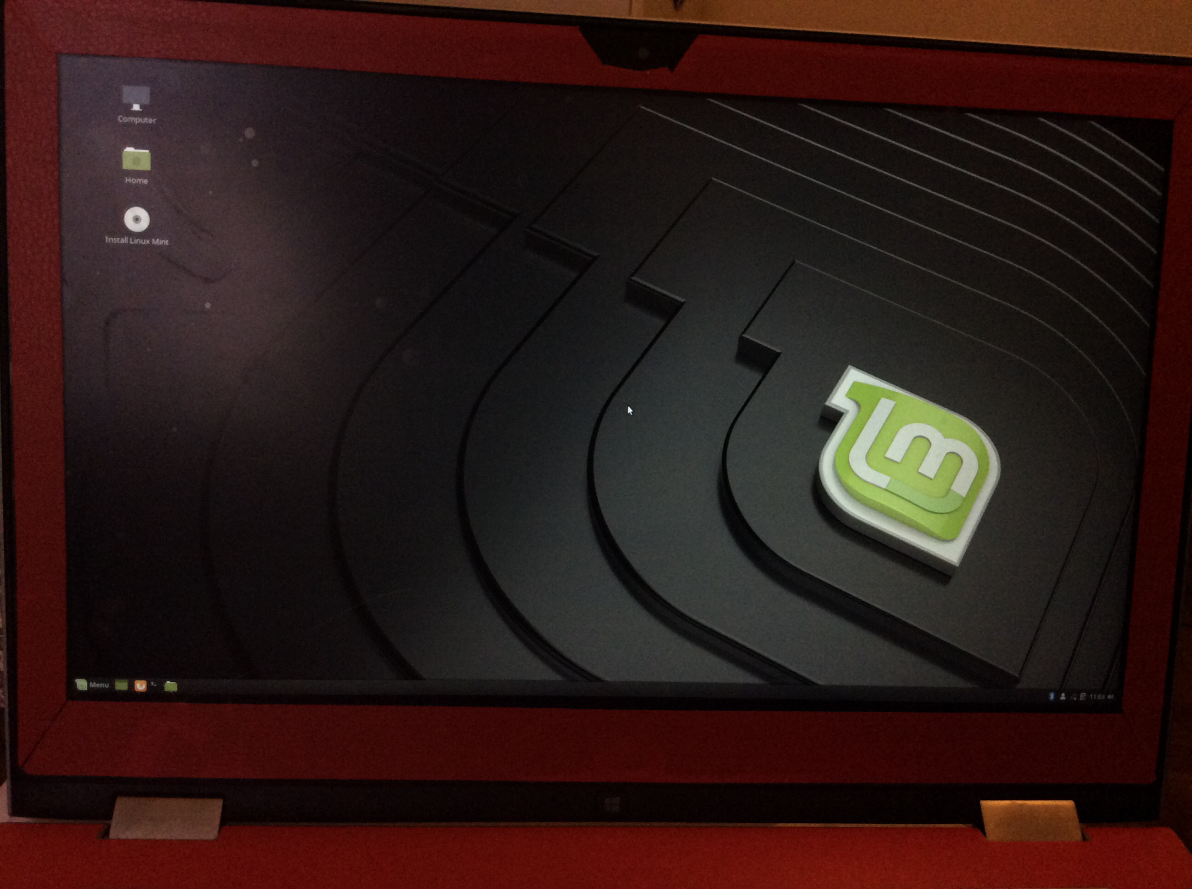  
Click on Install Linux mint icon to start actual booting via selecting language preference and select WiFi for internet connectivity as listed .  
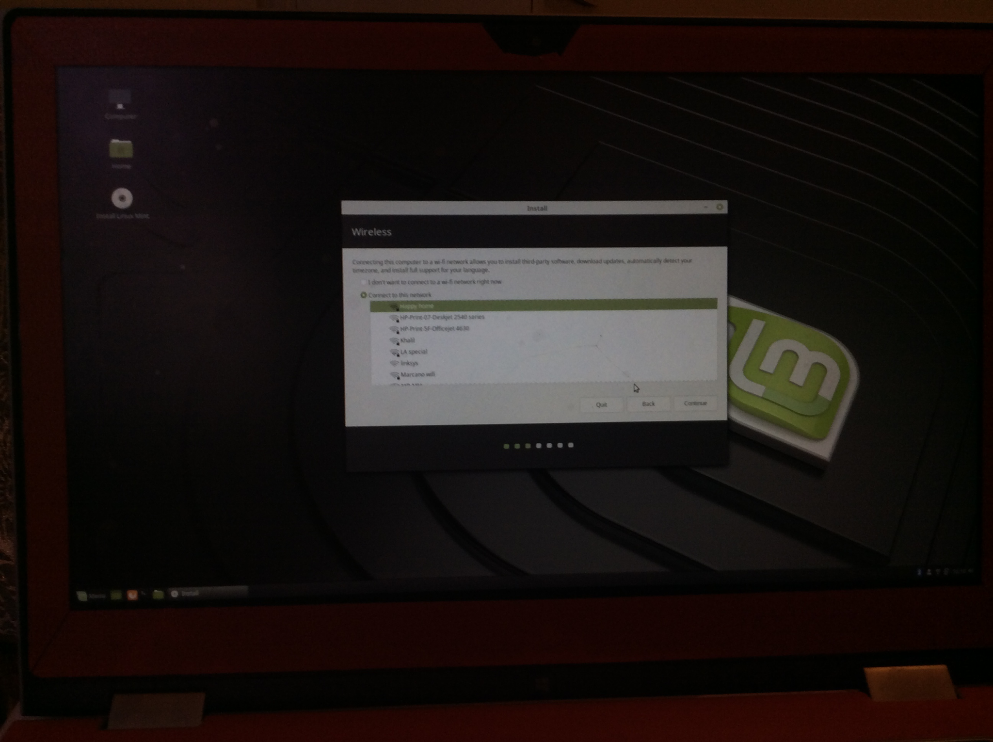

And must select INSTALL THIRD PARTY SW to install .and create a password .

If you willing to create a fresh linux select ERASE DISK AND INSTALL Linux MINT. Click on next and setup your location and username password step by step and let it be installed .it’s might take time so don’t worry about it.  
  
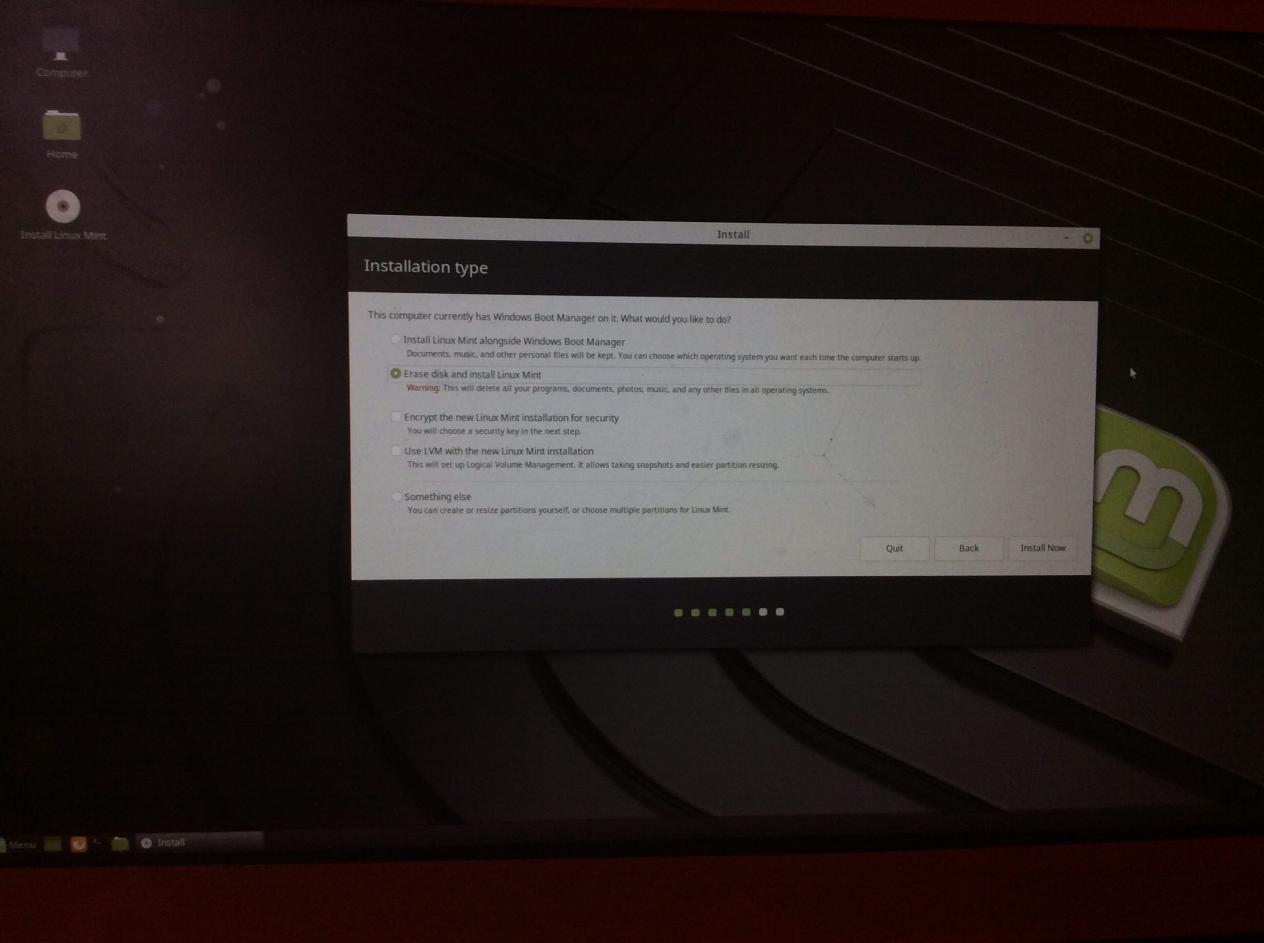  
Install JDK :from this website https://www.oracle.com/technetwork/java/javase/downloads/index.html accept and install licenses agreement How to add github project to Eclipse:  
  
Step 1: create or SignIn into your Github account   
Step 2: Start a Project / create a repository  
Step 3: Strat eclipse   
Step 4: go to prospective from the right upper corner >Git repository  
  
Click on Add existing local git repository > select file from browser and click on Add . It should come up like this   
  
  
Step 5: Create an eclipse project   
Step 6: do right click on project > team >share>add to git repository  
Step 7: commit and push the project to the repository   
Step 8: commit and push every change to the repository